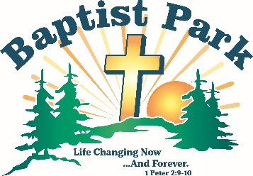
Baptist Park Snapshots
June 2026
PO Box 498, Mapleton, ME 04757
60 Park Road, Mapleton, ME (207) 764-1832 thebaptistpark@gmail.com www.baptistpark.net

What About Adults?
Yes, Baptist Park is for kids. But there’s plenty for adults, too. Invite your friends. Everyone is welcome at Baptist Park. Come on!
Evening Worship Every Sunday in July at 6:00 p.m. Preachers: Steve Straubel (7/5), Steve Burden (7/12), Al Fletcher (7/19), Dave Meyer (7/26). Each will speak on a different aspect of our summer theme Who Am I in Christ?
July 3 Freedom Celebration Open house at 1:00 p.m.; cookout meal at 4:00; worship in The Tab at 6:00; Mark Lunn Preaching; fireworks at 9:00. All for a donation. Come & go as you need.
Paint & Sip Friday July 24 is for men and women; Tuesday July 28 is ladies only. Both begin with a meal at 5:00 p.m.; painting at 6:00. $25/person; all materials provided.
July 25 Christian Life Conference The Great I AM: Worthy of Our Worship, Walk & Witness. Pastors Dave Goupille and Jim Ackerson will open God’s word regarding The Great I AM. $40/person. Registration at 8:30 a.m. Ends with the Noon meal.
Aug. 14-15 Men’s Retreat Men Who Walk with God Walk with Integrity. Friday, 6:00 p.m. registration followed by worship & campfire fellowship. Saturday, 8:00 a.m. registration and breakfast followed by worship, fun, food, and fellowship. $49/person.

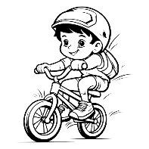
Bike Clinic
Pastor Ray Gough heads up our bike clinic. It has three components: (1) Camp Bikes: fully inspected and rigorously maintained to provide an enjoyable activity for our campers and others on staying on campus. (2) Bike Clinic: tune-ups and repair to anyone. Labor is free; parts are at cost. By appointment Mondays, June 29-July 27. Call to schedule an appointment. (3) Community Outreach: Used bikes are restored and donated in the name of Baptist Park during community events.

Here’s how you can help: (a) Donate used or damages bikes of all makes, models & sizes. (b) Donate loose bike parts. (c) Make a donation designated “bike clinic”. Contact Pastor Ray to if you have bikes or parts to donate: (207) 538-8620 Call/Text


Director’s Cut
lPTL: We’re fully staffed!
lNo SOWERS coming in June or July. Please help with basic maintenance (e.g. painting, light construction, etc.). Call Scott to discuss your interests, abilities & availability.


Pray without ceasing (1 Thess. 5:17)
lThe Lord to prepare & raise up campers for 2026.
lFor God’s anointing on our camp preachers.
lSafety for everyone working on campus.


Finances
Now’s the time to give to Baptist Park. Here’s how:
Cash Donations Every gift matters, whether large or small. Mail to: Baptist Park, PO Box 498, Mapleton, ME 04757. Returnables Take returnable bottles & cans to Presque Isle Redemption, 2 Washburn Rd., P.I. & donate them to Baptist Park. Donate Appreciated Stock Donate publicly traded stock or mutual funds. Call us for details. Qualified Charitable Distributions (QCDs) Individuals age 70.5 or older may be eligible to make a QCD directly from an IRA to Baptist Park. QCDs can satisfy a Required Minimum Distribution (RMD) and are generally excluded from taxable income. Call us for details.

