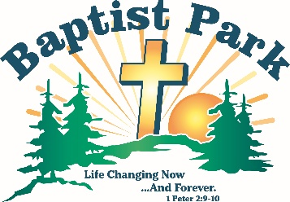
Baptist Park Snapshots
August 2026
PO Box 498, Mapleton, ME 04757
60 Park Road, Mapleton, ME (207) 764-1832 thebaptistpark@gmail.com www.baptistpark.net

But Wait, There’s More!
Yes, weekly camps are done for 2026, but the season isn’t over. We want to see you at Baptist Park for the next two events.

Men’s Retreat, Friday, Aug. 14 & Saturday, Aug. 15; $49

We’re bringing back men’s retreat after about 20 years without one. Registration begins at 6:00 p.m. on Friday. We’ll worship and then enjoy fellowship around the campfire. Saturday, registration is from 8:00-9:00 a.m. followed by breakfast, two worship sessions, lunch and activities (some of which will go “bang”).

We challenge every church to bring at least 5 guys. Spend the night Friday in one of our cabins; or sleep in your own bed and come back Saturday. Want to bring your camper or sleep in a tent? Give us a call and we’ll reserve your spot. Or come for Saturday only. Just come, guys!

Michael Sullivan will speak on the theme “Men Who Walk with God, Walk with Integrity.” Men, come be encouraged to walk with integrity.

But you, man of God, flee from all this, and pursue righteousness, godliness, faith, love, endurance and gentleness. Fight the good fight of the faith. Take hold of the eternal life to which you were called when you made your good confession in the presence of many witnesses. 1 Timothy 6:11-12 NIV
Aroostook County Youth Rally & Retreat
Friday, Sept. 4, 5:00 p.m. – Sunday, Sept. 6, 3:00 p.m.
Grades 6-12 $60/person

Every church youth group in Aroostook, regardless of denomination, is invited to Baptist Park for a weekend full of activities, worship and exploring the questions: Who am I in Christ? Why am I here? What’s wrong with this world? How can we make it right? Where am I going? How can I witness to my friends?

This is the first time we’ve ever attempted to bring Christian teens and their leaders together from all across Aroostook for worship and fellowship at Baptist Park. May the Lord place His mighty hand on Aroostook youth.

Spread the word to churches, youth groups and teens you know. We want Baptist Park packed with teens eager to grow in their relationship with Christ. Ask the Lord to do a great work in those who attend, and do what you can to get them there.


Finances
“How’s the checkbook?” is a typical question this time of year. We’re grateful to report that summer income was stable. There wasn’t a lot extra, but we made it. Now we have to finish the work.

Please give. Donations from individuals and churches are necessary so we can pay the last of the bills. No donation is too small. Every dollar counts.

Mail your gift to: Baptist Park, PO Box 498, Mapleton, ME 04757

