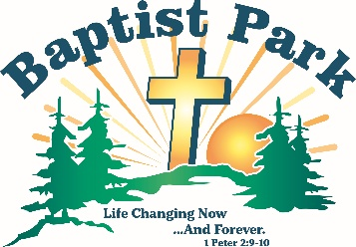
Baptist Park Snapshots
September 2026
PO Box 498, Mapleton, ME 04757
60 Park Road, Mapleton, ME (207) 764-1832 thebaptistpark@gmail.com www.baptistpark.net


Aroostook County Youth Rally & Retreat Canceled
With regret, we announce the cancelation of the County-wide youth rally planned for Sept. 4-6. There just wasn’t enough interest.


Camping Season Celebrations
While our volunteers are still mining information from the 2026 season for concrete data, we are able to report in general terms that God blessed in many ways:

- Camper attendance was up.
- 6-8 first-time decisions for Christ that we know of.
- Sunday Evening worship services were well-attended.
- Men’s Retreat was well-attended after a twenty year hiatus.
- Finances stable; only routine bills outstanding at this point.
- Wood splitter campaign successful. Enough money was raised to purchase the one we had in mind. After that, someone donated a used one to Baptist Park.

Baptist Park Available Remember, anyone can enjoy Baptist Park any time. Come enjoy a peaceful stroll or picnic on the grounds. Want to have an organized event? Reach out to Scott ASAP to discuss details. Buildings will be winterized and closed beginning in October.

Wood Splitting Party We’ll announce on Facebook when help is needed to split and pile our firewood. We’ll provide lunch; you provide joyful, willing workers. We sincerely thank and recognize Columbia Forest Products for their annual block wood donation.


Director’s Cut
Thank you to everyone who helped at Baptist Park this summer. Your role is deeply appreciated whether you were paid staff or one of our many volunteers; one of our faithful donors; or one of our unseen prayer warriors. Eternity alone will show how important your role was. Thank you!!


Pray without ceasing (1 Thess. 5:17)
lGive thanks for all the ways God worked and provided this summer.
lAsk God to continue his work in our campers, drawing them ever closer to Christ.
lPray for the Board; planning for 2027 has already begun.

Finances

Your donation to Baptist Park is appreciated as we approach the finish line of funding the 2026 season. Here are ways you can give to this life changing work.
lCash Donations Regular giving from churches & individuals is our financial backbone. Mail all donations to: Baptist Park, PO Box 498, Mapleton, ME 04757.
lReturnables Take returnable bottles & cans to Presque Isle Redemption, 2 Washburn Rd., P.I. & donate them to Baptist Park.
lDonate Appreciated Stock Donate publicly traded stock or mutual funds. Call us for details.
lQualified Charitable Distributions (QCDs) Individuals age 70.5 or older may be eligible to make a QCD directly from an IRA to Baptist Park. QCDs can satisfy a Required Minimum Distribution (RMD) and are generally excluded from taxable income. Call us for details.

